Final Implementation Report

Project Title: IntelliStudy – Smart Learning Assistant

Name: Vemuri Sarvani
Roll Number: 23WU0102224
Team: AIML Panthers

Introduction
IntelliStudy – Smart Learning Assistant is a mini machine learning project demonstrating the workflow from data preprocessing to model deployment. It uses the Iris dataset and a Random Forest Classifier to predict flower species, aiming to strengthen ML understanding and placement readiness.

Technical Stack
• Programming Language: Python
• Libraries: scikit-learn, joblib, numpy
• Environment: Jupyter Notebook / VS Code
Tech & Behavioral Skills Map Implementation
• SQL & Web Development: Revised core concepts, practiced through online exercises, and built mini web-based applications.
• Cloud Computing & Machine Learning: Explored AWS fundamentals and implemented small ML models using Python and scikit-learn.
• Problem Solving & Positive Attitude: Practiced problem-solving on platforms like LeetCode and maintained a consistent, growth-oriented mindset.
• Communication & Confidence: Participated in mock interviews and group discussions to improve articulation and presentation of ideas.

Functional Features
• Loads and splits the Iris dataset into training and testing sets.
• Trains a RandomForestClassifier model and evaluates its accuracy.
• Saves the trained model and summary reports as proof artifacts.
• Includes a prediction script using the saved model.

SMART Action Plan
I worked on core technical subjects like SQL, Web Development, and Machine Learning.
I tracked progress through weekly goals and coding logs, noting improvements in problem-solving speed and accuracy.
By dedicating 3–4 hours weekly, I successfully completed my set learning and project milestones.
I developed and deployed small projects to practically demonstrate my understanding of concepts.
Noticeable improvement was achieved within one month, as seen from my project outcomes and mock interview feedback.

Technical Skills Demonstrated
1. Data handling and preprocessing.
2. Model building and evaluation using scikit-learn.
3. Model persistence using joblib.
4. Debugging and optimizing workflow execution.

Behavioral Skills Demonstrated
• Problem Solving: Tackled dependency and syntax errors during model execution.
• Time Management: Maintained weekly milestones for training, testing, and documentation.
• Learning Agility: Adapted to ML workflow tools and GitHub integration quickly.
• Collaboration: Discussed best practices with peers and mentors.

Screenshots & Sample Outputs
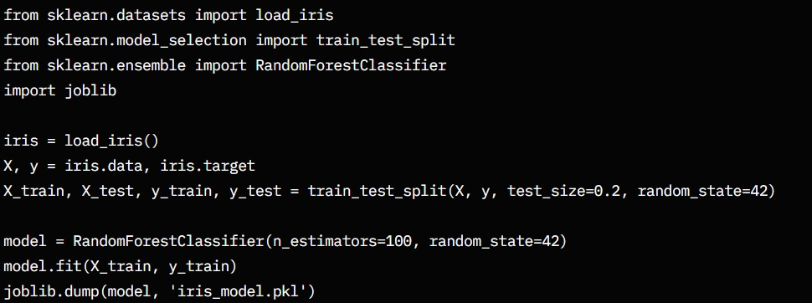

Conclusion
This project significantly improved my technical and analytical skills in the field of Machine Learning. I learned to manage complete ML pipelines, debug efficiently, and understand the significance of model evaluation metrics. Completing IntelliStudy made me more confident and placement-ready. Future work includes adding a web interface using Flask for real-time predictions and visualization.

